Saint Peter's Square
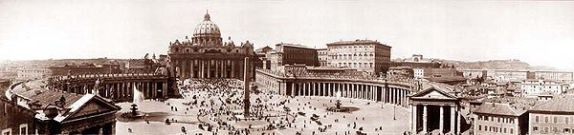

History of St. Peter's Square
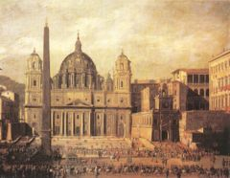
The open space which lies before the basilica was redesigned by Gian Lorenzo Bernini from 1656 to 1667, under the direction of Pope Alexander VII, as an appropriate forecourt, designed "so that the greatest number of people could see the Pope give his blessing, either from the middle of the façade of the church or from a window in the Vatican Palace" (Norwich 1975 p 175). Bernini had been working on the interior of St. Peter's for decades; now he gave order to the space with his renowned colonnades, using the Tuscan form of Doric, the simplest order in the classical vocabulary, not to compete with the palace-like façade by Carlo Maderno, but he employed it on an unprecedented colossal scale to suit the space and evoke emotions of awe.

The Piazza as it was in 1630, painted by Viviano Codazzi
The site's possibilities were under many constraints from existing structures (illustration, right). The massed accretions of the Vatican Palace crowded the space to the right of the basilica's façade; the structures needed to be masked without obscuring the papal apartments. The obelisk marked a center, and a granite fountain by Carlo Maderno stood to one side: Bernini made the fountain appear to be one of the foci of the ellipse^{[2]} embraced by his colonnades and eventually matched it on the other side, in 1675, just five years before his death. The trapezoidal shape of the piazza, which creates a heightened perspective for a visitor leaving the basilica and has been praised as a masterstroke of Baroque theater (illustration, below right), is largely a product of site constraints.
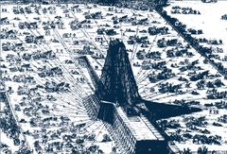
The colossal Tuscan colonnades, four columns deep, frame the trapezoidal entrance to the basilica and the massive elliptical area which precedes it. The ellipse's long axis, parallel to the basilica's façade, creates a pause in the sequence of forward movements that is characteristic of a Baroque monumental approach. The colonnades define the piazza. The elliptical center of the piazza, which contrasts with the trapezoidal entrance, encloses the visitor with "the maternal arms of Mother Church" in Bernini's expression. On the south side, the colonnades define and formalize the space, with the Barberini Gardens still rising to a skyline of umbrella pines. On the north side, the colonnade masks an assortment of Vatican structures; the upper stories of the Vatican Palace rise above.

Re-erection of the obelisk in 1586

At the center of the ellipse stands an Egyptian obelisk of red granite, 25.5 meters tall, supported on bronze lions and surmounted by the Chigi arms in bronze, in all 41 meters to the cross on its top. The obelisk, of the 13th century BC, was moved to Rome in AD 37 by the Emperor Caligula to stand in the central spina of the Circus Gai et Neronis, which lay to the left of the present basilica. It was moved to its current site in 1586 by the engineer-architect Domenico Fontana under the direction of Pope Sixtus V; the engineering feat of re-erecting its vast weight was memorialized in a suite of engravings (illustrated right). The Vatican Obelisk is the only obelisk in Rome that has not toppled since ancient Roman times. During the Middle Ages, the gilt ball on top of the obelisk was believed to contain the ashes of Julius Caesar.^{[5]} Fontana later removed the ancient metal ball, now in a Rome museum, that stood atop the obelisk and found only dust. Though Bernini had no influence in the erection of the obelisk, he did use it as the centerpiece of his magnificent piazza.
The paving is varied by radiating lines in travertine, to relieve what might otherwise be a sea of cobblestones. In 1817 circular stones were set to mark the tip of the obelisk's shadow at noon as the sun entered each of the signs of the zodiac, making the obelisk a gigantic sundial's gnomon. Below is a fabulous view of St. Peter's Square from the cupola (the top of the dome) which was taken in June, 2007.
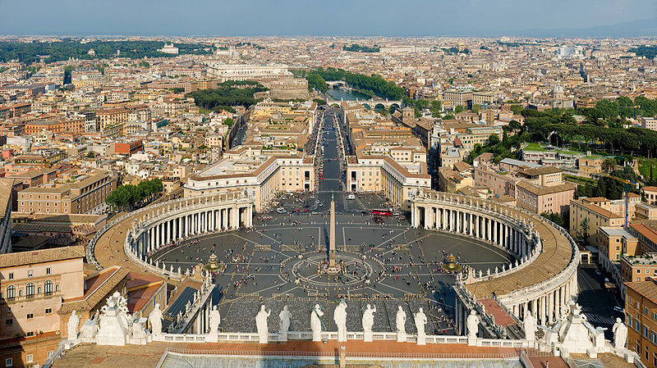
View of Rome from the Dome of St. Peter's Basilica
St. Peter's Square today can be reached from the Ponte Sant'Angelo along the grand approach of the Via della Conciliazione (in honor of the Lateran Treaty of 1929). The spina which once occupied this grand avenue leading to the square was demolished ceremonially by Benito Mussolini himself on October 23, 1936 and was completely demolished by October 8, 1937. St. Peter's Basilica was now freely visible from the Castel Sant Angelo. The effect of its demolition, however, was to destroy the characteristic Baroque "surprise". The Via della Conciliazione was completed in time for the Great Jubilee of 1950.
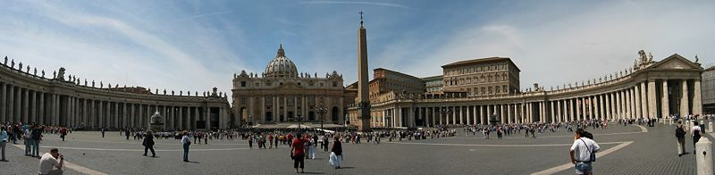
St. Peter's Square (facing Saint Peter's Basilica), and the obelisk from the Circus of Nero

