Vatican Museums
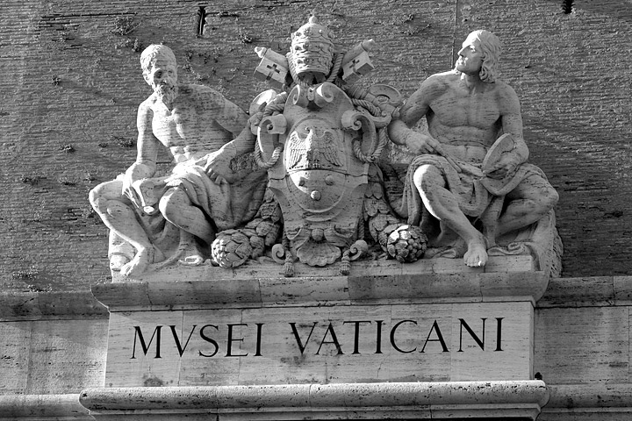

The Vatican Museums (Italian: Musei Vaticani), in Viale Vaticano in Rome, inside the Vatican City, are among the greatest museums in the world, since they display works from the immense collection built up by Roman Catholic Church throughout the centuries.
Pope Julius II founded the museums in the 16th century. The Sistine Chapel and the Stanze della Segnatura decorated by Raphael are on the visitor route through the Vatican Museums.
As of 2007, they were visited by 4,310,083 people for the year

Origins
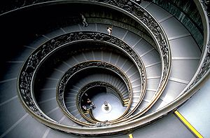
Staircase of the Vatican Museum
The Vatican Museums trace their origin to one marble sculpture, purchased 500 years ago. The sculpture of Laocoön, the priest who, according to Greek mythology, tried to convince the people of ancient Troy not to accept the Greeks' "gift" of a hollow horse, was discovered 14 January 1506, in a vineyard near the basilica of Santa Maria Maggiore in Rome. Pope Julius II sent Giuliano da Sangallo and Michelangelo Buonarroti, who were working at the Vatican, to examine the discovery. On their recommendation, the pope immediately purchased the sculpture from the vineyard owner. The pope put the sculpture of Laocoön and his sons in the grips of a sea serpent on public display at the Vatican exactly one month after its discovery.
The Museums celebrated their 500th anniversary in October 2006 by permanently opening the excavations of a Vatican Hill necropolis to the public.

Pinacoteca Vaticana
The collection was first housed in the Borgia Apartment, until Pope Pius XI ordered construction of a proper building. The designer was Luca Beltrami. The museum has works of art of painters including Michelangelo, Raphael and Fra Angelico.

Collection of Modern Religious Art
The Collection of Modern Religious Art houses paintings and sculptures from artists like Carlo Carrà and Giorgio de Chirico.

Sculpture museums
The group of museums includes several sculpture museums surrounding the Cortile del Belvedere.

Museo Pio-Clementino
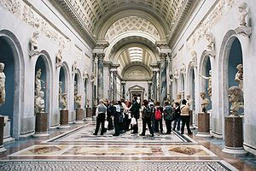
The New Wing, Braccio Nuovo built by Raphael Stern.
Pope Clement XIV founded the Pio-Clementino Vatican museum in 1771, and originally it contained the Renaissance and antique works. The museum and collection were enlarged by Clement's successor Pius VI. Today, the museum houses works of Greek and Roman sculpture.
There are 54 galleries, or "salas" in total, with the Sistine Chapel, notably, being the very last sala within the Museum - visitors need to proceed through the other 53 salas before earning their reward with access to the Sistine. Some notable galleries are:
- Sala a Croce Greca: which houses the sarcophagus of Constance and Saint Helen, daughter and mother of Constantine the Great.
- Sala Rotonda: holding several ancient mosaics and statues.
- Gallery of the Statues (Galleria delle Statue): Houses, as says its name, important statues like Ariadne sleeping and Meandrus. It also houses the Barberini Candelabrums.
- Bust Gallery (Galleria dei Busti): Several busts are displayed.
- Mask Cabinet (Gabinetto delle Maschere): The name comes from the mosaic in the floor of the gallery, found in Villa Adriana, which represents several masks. Along the walls, several famous statues are shown like the Three Graces.
- Sala delle Muse: Houses the group statues of Apollo and the nine muses. Statues from important Greek sculptors are exhibited.
- Sala degli Animali: So named because of the several statues of animals that it houses.
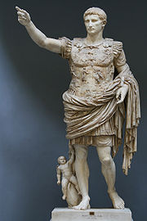
The Prima Porta Augustus.

Museo Chiaramonti
This museum is named after Pope Pius VII (whose last name was Chiaramonti before his election as pope), who founded it in the early 1800s. The museum consists of a large arched gallery in which sides are exhibited several statues, sarcophaguses and friezes. The New Wing, Braccio Nuovo built by Raphael Stern, houses important statues like The Prima Porta Augustus and The River Nile. Galeria Lapidaria is another part of Chiaramonti museum, with more than 3,000 stone tablets and inscriptions, which is the world's greatest collection of its kind. However, it is opened only by special permission, usually for reasons of study.

Museo Gregoriano Etrusco
Founded by Pope Gregory XIII in 1836, this museum has eight galleries and houses important Etruscan pieces, coming from archaeological excavations. The pieces include: vases, sarcophagus, bronzes and the Guglielmi Collection.

Museo Egiziano
Founded by Pope Gregory XVI, this museum houses a grand collection of Ancient Egyptian material. Such material includes papyruses, the Grassi Collection, animal mummies, and the famous Book of the Dead.

Works in the Vatican museums
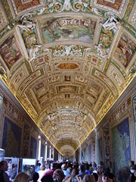
Gallery of Maps
- Several paintings by Caravaggio including the majestic Entombment (1602 - 1603)
- Leonardo da Vinci's portrait of Saint Jerome;
- Works by painters Fra Angelico, Giotto, Raphael, Nicolas Poussin and Titian;
- The red marble papal throne, formerly in the Basilica di San Giovanni in Laterano;
- Roman sculpture, tombstones, and inscriptions, including the epitaph of Lucius Cornelius Scipio Barbatus;
- The massive collection of works by the master Raphael including the masterpiece The School of Athens
- The Niccoline Chapel
- The Sistine Chapel
- The Gallery of Maps: topographical maps of the whole of Italy, painted on the walls by friar Ignazio Danti of Perugia, commissioned by Pope Gregory XIII (1572–1585). This gallery is situated at the west side of the Belvedere Courtyard. It is 120 m long. It took Ignazio Danti three years (1580–1583) to complete the 40 panels. The decorations on the vaulted ceiling is the work of a group of Mannerist artists (such as Cesare Nebbia and Girolamo Muziano).
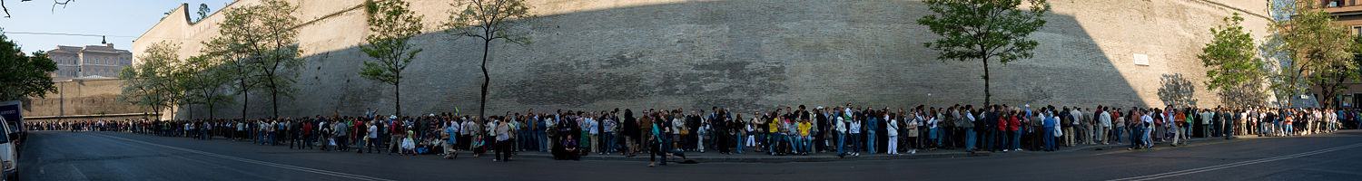
On the last Sunday of each month, the Vatican Museum is open to the public for free. This is extremely popular and it is common to wait in line for many hours. This image is a panoramic view of one small stretch of the entire queue in April 2007, which continues for some distance in both directions beyond view.

